SEFM Data README
Updated 5/22/2024

Tall Timbers Geospatial Center
sefiremap@talltimbers.org ______________________________________________________________________________
Overview
The Southeast FireMap (SEFM) represents annual burn detections, from 1994 through 2023, identified by delineating burn scars detected by Landsat throughout the southeastern United States over the historic range of the longleaf pine (Pinus palustris) and adjacent areas (Figure 1). Additionally, the data include fire history metrics that describe spatiotemporal patterns of fire occurrence over the entire study period. Provided is an overview of the data, an abridged methodology, a brief description of geodatabase available for download, detailed attribute and raster value definitions, a review of known data limitations, and an update log.
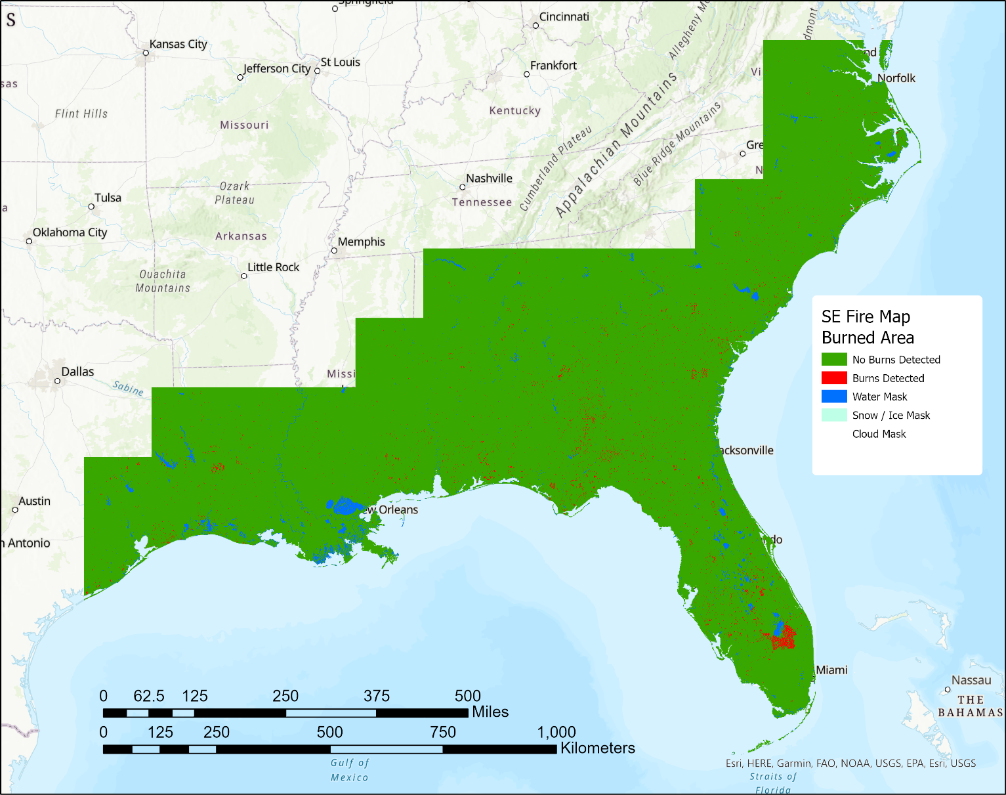
Figure 1: The annual Southeast FireMap burn classification raster for 2022 demosntrating the extent of the SEFM, the burned area classification, and related data masks.
______________________________________________________________________________
Methodology
Tall Timbers Research (TTR) Inc. produced the SEFM data using the United States Geological Survey’s (USGS) Landsat Burned Area (v2) (BA) (Hawbaker et al. 2020) product’s scene level burn probabilities (BP) as inputs, and methods established by Teske et al. (2021). Multiple Landsat Satellites with staggered orbits each pass over the same point on earth every 16 days, collecting an image with 30m x 30m resolution at least every 8 days (depending on how many Landsat satellites are in orbit at a given time). The USGS preprocess these images and publishes them as Analysis Ready Data (ARD) tiles ready for time-series investigative analysis (Dwyer et. al 2018). The Landsat BA product produces BP layers for any ARD tile scene with less than 80% cover and these were used as the initial input for the SEFM.
The BP layers within each year were aggregated by retaining the maximum BP for each pixel from all the available scenes for that year. Next, the maximum BP layers were thresholded at 90% to create an initial burn detection where any pixel with a BP greater than or equal to 90% was considered burned. A smoothing process using a 3 x 3 majority filter and a sieving process that removed any burn detections with fewer than 11, connected pixels (i.e. detections < 2.45 acres) reduced speckling and resulted in better-defined burned detections. This resulted in a burned area raster for each year. The rasters were also vectorized to produce polygon layers and attributed with land cover and burn date information.
Finally, a spatial join of all annual burned area polygon layers produced a polygon layer representing areas with shared fire histories over the study period. The unique fire history layer was attributed to show each year a burn was detected and to provide fire history metrics (FHM) that summarize the burn history.
_______________________________________________________________________________
Overview of Geodatabases Available for Download:
- BurnedAreaPolys.gdb - contains annual feature layers representing burn detections for any given year.

- BurnedAreaRasters.gdb - contains annual raster layers representing burn detections and data masks for any given year.

- FireHistoryMetrics.gdb - contains four raster layers representing fire history metrics (FHM) throughout the time series. Additionally, it contains a polygon layer representing pixels that have shared fire histories throughout the time series and binary burn presence/absence data for each year.
________________________________________________________________________________

Detailed Descriptions and Raster Value / Attribute Definitions

- BurnedAreaPolys.gdb – Feature layers showing burn detections for each calendar year. Burnes were defined as contiguous burned pixels regardless of burn detection dates. Years 2021 through 2023 also have attributes related to the timing of the fire, NLCD landcover classes, and LCMAP land cover classes within the fire footprint. Years 1994 through 2020 only have minimal attributes indicating the year the fire occurred, but the SEFM team is currently backwards processing the data to update these years with the additional attributes.

File Naming Convention: FiresOnly_Poly_YYYY
Attribute Defintions:

Years 2021 – 2023

ecol3 – majority level 3 ecoregion value for all ecoregion values within the polygon as defined by Omernik and Griffith (2014).
80301 = Northern Piedmont
80303 = Interior Plateau
80304 = Piedmont
80305 = Southeastern Plains
80306 = Mississippi Valley Loess Plains
80307 = South Central Plains
80308 = East Texas Central Plains
80401 = Ridge and Valley
80404 = Blue Ridge
80409 = Southwestern Appalachians
80501 = Middle Atlantic Coastal Plain
80502 = Mississippi Alluvial Plain
80503 = Southern Coastal Plain
90407 = Texas Blackland Prairies
90501= Western Gulf Coastal Plain
150401= Southern Florida Coastal Plain

h – horizontal Landsat Analysis Ready Data (ARD) tile coordinate

v – vertical Landsat Analysis Ready Data (ARD) tile coordinate

hv – analysis Ready Data (ARD) tile coordinate, combining horizontal and vertical coordiantes

year – year the fire was detected

count – count of 30m x 30m pixels within the fire detection

prebd_min – minimum pre-burn date, the earliest date of all burned pixels in the fire detection in which a clear, unburned view of the pixel was observed prior to detecting the pixel as burned, in the format YYYYMMDD.

prebd_max – maximum pre-burn date, the latest date of all burned pixels in the fire detection in which a clear, unburned view of the pixel was observed prior to detecting the pixel as burned, in the format YYYYMMDD.

prebd_mean – mean pre-burn date, the mean date of all burned pixels in the fire detection in which a clear, unburned view of the pixel was observed prior to detecting the pixel as burned, in the format YYYYMMDD.

prebd_std – standard deviation of the pre-burn date, the date of all burned pixels in the fire detection in which a clear, unburned view of the pixel was observed prior to detecting the pixel as burned. **Note, there is currently a known bug in that causes an error with the prebd_std calculation. The SEFM team is working on resolving this.

bd_min – minimum date within the fire detection in which a pixel was observed as burned, in the format YYYYMMDD

bd_max – maximum date within the fire detection in which a pixel was observed as burned, in the format YYYYMMDD

bd_mean – mean date within the fire detection in which a pixel was observed as burned, in the format YYYYMMDD

bp_min – minimum burn probability within the fire detection footprint, from the Landsat BA maximum burn probability mosaic used as the input in the burn classification process.

bp_max – maximum burn probability within the fire detection footprint, from the Landsat BA maximum burn probability mosaic used as the input in the burn classification process.

bp_mean – mean burn probability within the fire detection footprint, from the Landsat BA maximum burn probability mosaic used as the input in the burn classification process.

bp_std – the standard deviation of the burn probability within the fire detection footprint, from the Landsat BA maximum burn probability mosaic used as the input in the burn classification process.

bc_min - Minimum burn classification count within the burned patch from the Annual Burn Count Classification product (LBA_CU_2023_20240301_C02_BC.tif)

nlcdr_x (e.g. nlcdr_11, nlcdr_42)– count of 30m x 30m pixels representing the National Land Cover Database (NLCD) value (Vogelmann et. al., 2001 and Yang et. al., 2018) of x within the burn detection.
Possible values of x:
11 = Open Water
12 = Perennial Ice/Snow
21 = Developed, Open Space
22 = Developed, Low Intensity
23 = Developed, Medium Intensity
24 = Developed, High Intensity
31 = Barren Land (Rock/Sand/Clay)
32 = Unconsolidated Shore
33 = Mixed Urban
41 = Deciduous Forest
42 = Evergreen Forest
43 = Mixed Forest
51 = Dwarf Scrub
52 = Shrub/Scrub
61 = Orchards/Vineyards/Other
71 = Grassland/Herbaceous
81 = Pasture/Hay
82 = Cultivated Crops
83 = Small Grains
84 = Fallow
85 = Urban/Recreational Grasses
90 = Woody Wetlands
91 = Palustrine Forested Wetland
92 = Palustrine Scrub/Shrub Wetland
93 = Estuarine Forested Wetland
94 = Estuarine Scrub/Shrub Wetland
95 = Emergent Herbaceous Wetlands

nlcdr_domi – The attribute label of the simplified NLCD category (e.g. nlcdr_x) that had the majority of burned pixels within the fire detection.
Possible values of nlcdr_domi:
11 = Open Water
12 = Perennial Ice/Snow
21 = Developed, Open Space
22 = Developed, Low Intensity
23 = Developed, Medium Intensity
24 = Developed, High Intensity
31 = Barren Land (Rock/Sand/Clay)
32 = Unconsolidated Shore
33 = Mixed Urban
41 = Deciduous Forest
42 = Evergreen Forest
43 = Mixed Forest
51 = Dwarf Scrub
52 = Shrub/Scrub
61 = Orchards/Vineyards/Other
71 = Grassland/Herbaceous
81 = Pasture/Hay
82 = Cultivated Crops
83 = Small Grains
84 = Fallow
85 = Urban/Recreational Grasses
90 = Woody Wetlands
91 = Palustrine Forested Wetland
92 = Palustrine Scrub/Shrub Wetland
93 = Estuarine Forested Wetland
94 = Estuarine Scrub/Shrub Wetland
95 = Emergent Herbaceous Wetlands

lcmap_x – count of 30m x 30m pixels representing the Land Change Monitoring, Assessment, and Projection (LCMAP) value (Brown et al. 2020) of x within the burn detection.
Possible values of x:
1 = Developed
2 = Cropland
3 = Grass/Shrub
4 = Tree Cover
5 = Water
6 = Wetland
7 = Ice/Snow
8 = Barren

Years 1994 – 2020

Id – numerical, sequential, unique identifier for each polygon.

gridcode – identifier used in data processing

BYYYY – 1 indicates the polygon burned in the given year. All values within a given annual layer will equal 1. This field is useful when calculating custom fire history metrics across multiple years.

FYEARYYYY – indicates the year the fire occurred. All values within an annual layer will be the same. This field is useful when calculating custom fire history metrics across multiple years.

- BurnedAreaRasters.gdb – Rasters showing burn detections for each calendar year and data masks for clouds, water, and no-data. Burn detections are the raster equivalent of burn detections in BurnedAreaPolys.gdb.
File Naming Convention: BurnedArea_YYYY_90BP_SE
Raster Value Definitions:
0 = No fires detected this year.
1 = At least 1 fire detected this year
248 and 249 = Extreme values, suspicious data
251 = Water

252 = Snow and ice

253 = Clouds

254 = Cloud shadows

255 = No data / fill

- FireHistoryMetrics.gdb – Rasters showing fire history metrics (Teske et al. 2021) from 1994 through 2023.

SE_FRQ_94to23 – raster indicating Fire Frequency (FRQ), or the number of years that a burn was detected in each pixel. Ranges from 1 to 30.

SE_LFFI_94to23 – raster indicating the Longest Fire Free Interval (LFFI), or the greatest number of consecutive years in which no burns where detected between 1994 and 2023. This raster does not account for any years prior to 1994. Ranges from 1 to 29.

SE_TSPF_94to23 – raster indicating the Time Since Previous Fire (TSPF), or the number of years between 2023 and the year of the last detected fire in the pixel. For example, if a given pixel burned in 2023, the TSPF would be 0 years. Similarly, if a pixel last burned in 2020, the TSPF would be 3 years. Ranges from 0 to 29.

SE_YLB_94to23 – raster indicating the Year Last Burned (YLB), or the year value that the last burn was detected in the pixel. Ranges from 1994 to 2023.

SE_UniqueFireHistories_94to23 – Polygon layer representing areas with shared fire histories (i.e. contiguous pixels with the same pattern of burned/unburned years) throughout the time series. Each polygon in this layer is attributed with the years fire was detected and FHMs. This layer is useful for calculating custom FHMs over user-defined time intervals.

Attribute Definitions:

BYYYY (e.g. B1994, B1995…) – binary field indicating if a burn was detected in the referenced year where 1 means a burn was detected and a null value indicates no burn was detected.

FYEARYYYY (e.g. FYEAR1995, FYEAR1996…) – fields providing the year value for all years that a burn was detected.

FRQ – Fire Frequency, or the number of years that a burn was detected the polygon. Ranges from 1 to 30. Calculated as the sum of all BYYYY fields. The polygon attribute version of SE_FRQ_94to23.

LFFI - Longest Fire Free Interval, or the greatest number of consecutive years in which no burns where detected between 1994 and 2023. This raster does not account for any years prior to 1994. Ranges from 1 to 29. The polygon attribute version of SE_LFFI_94to23.

YLB – Year Last Burned, or the year value that the last burn was detected in the polygon calculated as the maximum of the FYEARYYYY fields. Ranges from 1994 to 2023. The polygon attribute equivalent of SE_YLB_94to23.

TSPF – Time Since Previous Fire, or the number of years between 2023 and the year of the last detected fire in the pixel calculated as 2023 - YLB. The polygon attribute equivalent of SE_TSPF_94to23.

_______________________________________________________________________

Known Limitations

There are instances where known fires may not be mapped and other instances where fires are mapped but no known fires actually occurred (or did not fully burn); these are documented and known issues and limitations of using 30m remotely sensed products (see Vanderhoof et al. 2017). Possible causes of these errors that have been identified are:

- In agricultural and developed areas, frequent changes in site conditions (green vegetation, non-photosynthetic vegetation, burned, tilled) make it challenging to use change-detection approaches to distinguish burn events (Vanderhoof et al. 2017).
- High soil moisture levels and consequently patchy (low severity) fires can also confound detection in certain circumstances. Wet soils can be much darker than dry soils, and may be misclassified as burned areas (Flasse et al. 2004).
- Impediments to burned area detection include rapid green-up following a burn, cloud cover preventing a view of the land surface, cloud shadows appearing as burned areas, difficulty detecting or differentiating low intensity burns beneath tree canopies, and the spatial resolution off satellite imagery being too coarse to capture fine-scale differences or small burns (Hawbaker et al. 2008, 2017).

Considerations for Users

These data represent the general ecological pattern of fire in the southeastern United States, and the FHMs can be used to help describe and analyze the fire regimes found in various ecosystems on both public and private lands. The data provided herein may not represent all fires and should not be considered a census database of known fire records. These Burned Area and Fire History products are meant to supplement local and regional expert knowledge by providing a seamless fire regime product to assist in management decisions, especially in those areas where fire records are currently not required or kept. Users should be aware of the following considerations:

- Fire history metrics produced by this product are not meant to replace local products but rather supplement known products where data gaps occur.
- The spatial resolution of the raster products used to produce the fire history metrics is 30 meters and while individual fires can represent a grouping as small as 11, 30-meter pixels, the application scale of the product is much larger in most cases.
- There are instances where known fires may not be mapped and other instances where fires are mapped but no known fires actually occurred (or did not fully burn); these are documented and known issues and limitations of using 30m remotely sensed products (see Vanderhoof et al. 2017).
- This product supports regional and sub-regional analysis and may be inappropriate for site specific analysis given the limitations described above.

________________________________________________________________________________

Update Log

March 2024 – New Updates since Previous Data Release
- Added additional attributes to to BurnedAreaPolys.gdb indicating land cover for 2023, 2022, and 2021. Land cover data for 2020 and earlier are not yet available but backwards processing to produce land cover data for these years is ongoing.
- Added additional attributes to BurnedAreaPolys.gdb for 2023, 2022, and 2021 that indicate the date range when the fires could have occurred instead of only providing the first earliest detection date.
- Stopped hosting the MaskedRasters.gdb as it can easily be derived from BurnedAreaRasters.gdb by masking out all values except 1.
- Stopped hosting YearRasters.gdb as it was redundant with BurnedAreaRasters.gdb, and can easily be derived from BurnedAreaRasters.gdb by masking all values except 1, and then multiplying each annual raster by the year it represents.
- Clarified reference date for Time Since Previous Fire (TSPF). TSPF is calculated as the last year in the time series (currently 2023) minus the last year a fire occurred. For example, if a given pixel burned in 2023, the TSPF would be 0 years. Similarly, if a pixel last burned in 2020, the TSPF would be 3 years.

March 2023

  - Consistently applied cloud, water, and no data masks across all years in the BurnedAreaRasters.gdb
  - Identified an error in code that set lower sieving threshold to 11 pixels (e.g., 11 instead of 10 pixels as was previously documented) and updated metadata to correctly document the larger minimum size.
  - Used Landsat Collection 2 Analysis Ready Data (ARD) for 2020 onward
  - Added ARD tiles h026v019, h027v019, h026v020, h027v020 which encompass the Florida Everglades and the Florida Keys. These tiles are out of the historic longleaf pine range, but still have pyrophytic communities where fire is a frequent and natural occurrence.

________________________________________________________________________________

References

Brown, F.J., Tollerud, H.J., Barber, C.P., Zhou, O., Dwyer, J.L., Vogelmann, J.E., Loveland, T.R., Woodcock, C.E., Stehman, S.V., Zhu, Z., Pengra, B.W., Smith, K., Horton, J.A., Xian, G., Auch, R.F., Sohl, T.L., Sayler, K.L., Gallant, A., Zelenak, D., Reker, R.R., & Rover, J., (2020). Lessons learned implementing an operational continuous United States national land change monitoring capability: The Land Change Monitoring, Assessment, and Projection (LCMAP) approach. Remote Sensing of Environment 238, 111356. https://doi.org/10.1016/j.rse.2019.111356.

Dwyer, J.L., Roy, D.P., Sauer, B., Jenkerson, C.B., Zhang, H., & Lymburner, L., (2018). Analysis ready data—Enabling analysis of the Landsat archive. Remote Sensing, 10(9), 1363. https://doi.org/10.3390/rs10091363.

Flasse, S. I., Trigg, S. N., Ceccato, P. N., Perryman, A. H., Hudak, A. T., Thompson, M. W., & le Roux, J. (2004). Remote sensing of vegetation fires and its contribution to a fire management information system. Wildland Fire Management Handbook for Sub-Saharan Africa; Global Fire Monitoring Centre (GFMC): Freiburg, Germany, 158-211.

Hawbaker, T. J., Vanderhoof, M. K., Beal, Y.-J., Takacs, J. D., Schmidt, G. L., Falgout, J. T., Williams, B., Fairaux, N. M., Caldwell, M. K., Picotte, J. J., Howard, S. M., Stitt, S., & Dwyer, J. L., (2017). Mapping burned areas using dense time-series of Landsat data. Remote Sensing of Environment, 198, 504–522. https://doi.org/10.1016/j.rse.2017.06.027

Hawbaker, T.J., Vanderhoof, M.K., Schmidt, G.L., Beal, Y.-J., Picotte, J.J., Takacs, J.D., Falgout, J.T., & Dwyer, J.L., (2020). The Landsat Burned Area algorithm and products for the conterminous United States. Remote Sensing of Environment 244, 111801. https://doi.org/10.1016/j.rse.2020.111801

Omernik, J.M., & Griffith G.E., (2014). Ecoregions of the conterminous United States: evolution of a hierarchical spatial framework. Environ Manage. 54(6):1249-66. doi: 10.1007/s00267-014-0364-1. Epub 2014 Sep 16. PMID: 25223620.

Teske, C., Vanderhoof, M. K., Hawbaker, T. J., Noble, J., & Hiers, J. K., (2021). Using the Landsat Burned Area Products to Derive Fire History Relevant for Fire Management and Conservation in the State of Florida, Southeastern USA. Fire, 4(2), 26. https://doi.org/10.3390/fire4020026

Vanderhoof, M. K., Fairaux, N., Beal, Y.J. G., & Hawbaker, T. J., (2017). Validation of the USGS Landsat Burned Area Essential Climate Variable (BAECV) across the conterminous United States. Remote Sensing of Environment, 198, 393–406. https://doi.org/10.1016/j.rse.2017.06.025

